ISEC2077 : Assignment 4
W0400411
By Mohammad Al Jokhadar

Table of Contents
Task 1 – Audit Policy Changes 4
Steps to retrieve Log Events : 4
Description : 4
Reasoning : 4
5
Description : 5
Reasoning : 5
Description : 6
Reasoning : 6
Event ID/s: 4728,4732 6
Description : 6
Reasoning : 7
Event ID/s: 4698 7
Description : 7
Reasoning : 7
Description : 8
Reasoning : 9
9
Description : 9
Reasoning : 9
Description : 10
Reasoning : 10
Steps to enable auditing : 11
Launch gpedit.msc after utilizing Make me Admin to have administrative privileges for a PowerShell terminal, and then navigate to : Computer Configuration à Windows Settings à Security Settings à Advanced Audit Policy Configuration à System Audit Policies – Local Group Policy Object 11
Account Management --> Audit User Account Management : 12
... followed by Logon/Logoff --> Audit Logoff : 14
Next, we shift to the Policy Change --> Audit Audit Policy Change: 15
Auditing audit policy changes would indicate to a defender a common tactic used by attackers, which is to cover their tracks by altering or disabling the auditing policy. 15
Next, we shift to the Object Access --> Audit Removable Storage: 16
... followed by Logon/Logoff --> Audit Account Lockout : 17
Significance: 17
… finally, I have opted to Audit Group Membership to track down any attempts to add the local user to the security-enabled groups : 18
Significance: 18
Task 2 – Event Creation 19
Bibliography 27

Assignment’s Preparation

Steps to retrieve Log Events :

In order to make the changes to NXLog;s configuration, we have to stop the NXLog service :
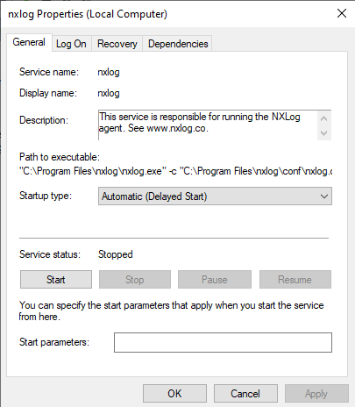
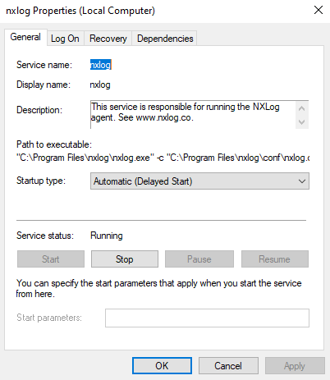
Methodology :
This is done by launching the services.msc application, finding the nxlog service, open its properties and then clicking on Stop.
Figure 2 –NXLog service is stopped
Figure 1 – Stopping the NXLog service

The nxlog.conf file configuration

Locate the nxlog.conf file

In order to make the changes to NXLog’s nxlog.conf file, we must locate it, and to be on the safe side, a backup copy of the file is made :
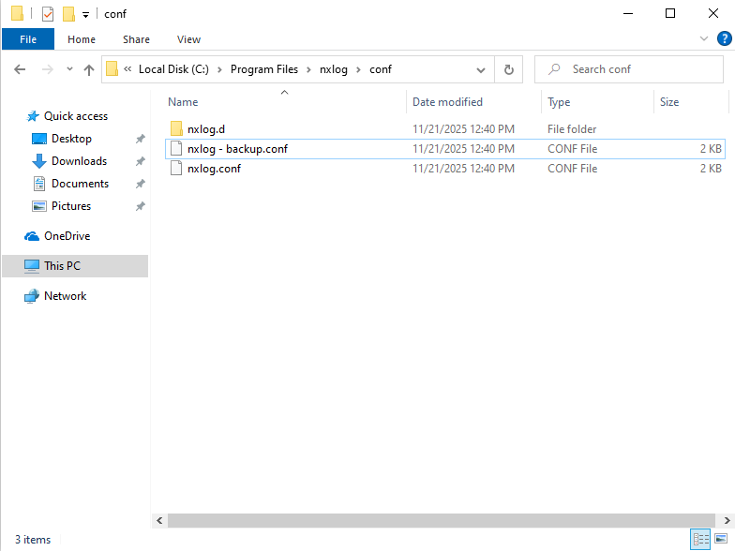

Figure 3 – Location of the nxlog.conf file

File Location :
C:\Program Files\nxlog\conf\nxlog.conf

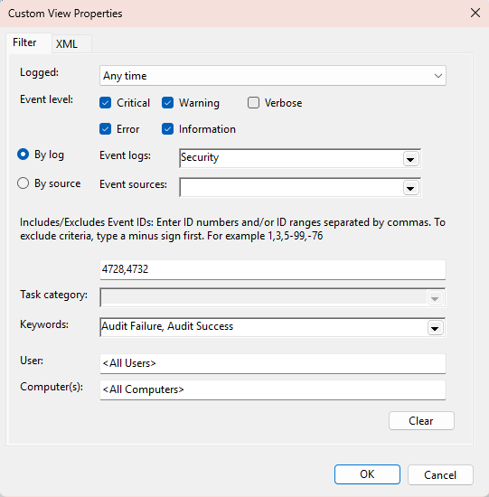
A User has been added to an Administrator group
Figure 4 - Screenshot showing a user being added to a security-enabled group, indicating privilege escalation

Event ID/s:
4728,4732

Description :
This policy would alert the administrator of events pertaining to the addition of a new member to a security-enabled global and local groups. This is significant due to the elevation of privilege that is being granted to the new member. Both events in question, in terms of local and global security-enabled groups, would provide the name of the user, name of the group, and the name of the computer as parts of a log entry (Windows Security Log Event ID 4728 - A Member Was Added to a Security-Enabled Global Group, n.d.; Windows Security Log Event ID 4732 - A Member Was Added to a Security-Enabled Local Group, n.d.).
Reasoning :
Audit Failures and Audit Success were selected due to the importance of knowing all failed privilege escalation attempts. Furthermore, the Critical, Warning, Error and Information Event Levels were selected to have a complete picture of across the different levels of criticality.
Windows Security Log Event ID 4728—A member was added to a security-enabled global group. (n.d.). Retrieved November 6, 2025, from https://www.ultimatewindowssecurity.com/securitylog/encyclopedia/event.aspx?eventid=4728
Windows Security Log Event ID 4732—A member was added to a security-enabled local group. (n.d.). Retrieved November 6, 2025, from https://www.ultimatewindowssecurity.com/securitylog/encyclopedia/event.aspx?eventid=4732

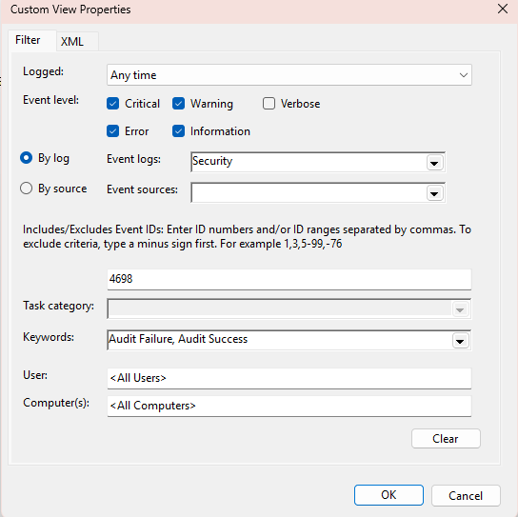
A New Scheduled Task has been created
Figure 5 - Screenshot of Event ID 4698, showing the creation of a new scheduled task by the user

Event ID/s:
4698
Description :
This policy would alert the administrator of events pertaining to the creation of a new scheduled task. It will provide the name of the user, the task name, and the path to the Task Scheduler application as parts of a log entry (Windows Security Log Event ID 4698 - A Scheduled Task Was Created, n.d.).
Reasoning :
Audit Failures and Audit Success were selected due to the importance of knowing all failed and successful attempts. Furthermore, the Critical, Warning, Error and Information Event Levels were selected to have a complete picture of across the different levels of criticality.
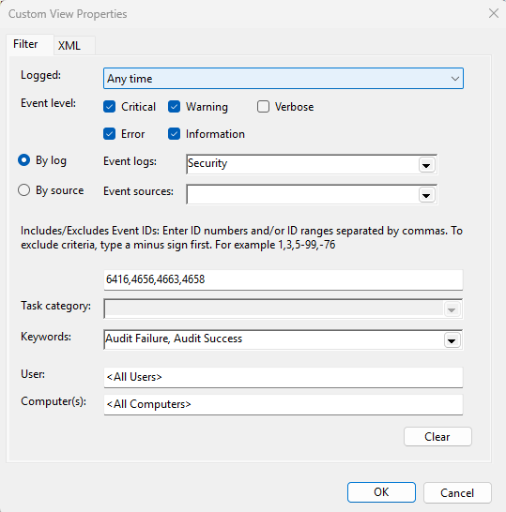
Windows Security Log Event ID 4698—A scheduled task was created. (n.d.). Retrieved November 6, 2025, from https://www.ultimatewindowssecurity.com/securitylog/encyclopedia/event.aspx?eventid=4698

File written to external storage
Event ID/s:
6416,4656,4663 with WriteData and 4658
Description :
This policy would alert the administrator of events pertaining to attempts to access an object, which would be in this case the USB drive. The following Event IDs were added to reflect the different stages of the process of writing a file to an external USB drive (according to the valuable guidance from Chapter 7 Object Access Events, n.d.) :
Figure 6 - Screenshot of Event IDs 6416, 4656, 4663 and 4658 capturing access to a USB device and file write operation
1. 6416 : A new external device was recognized by the system
Description : When a new external drive is connected, the event is logged (Windows Security Log Event ID 6416 - A New External Device Was Recognized by the System., n.d.)
2. 4656 : A handle to an object was requested
Description : This would be the first event to be recorded. In terms of obtaining access permissions to an object (such as a file or a folder being audited), this event indicates the actual request. In order to see what the results of the handle request (whether it may be Read Access or Write Access and so on), we would examine Event ID 4663 (Windows Security Log Event ID 4656 - A Handle to an Object Was Requested, n.d.).
3. 4663 : An attempt was made to access an object
Description : This event keeps track of actual actions being done on objects, such as a file in our case (where we would see WriteData in the log if data is being written, or AddFile if a new file is added). This event is preceded by Event ID 4656 (A handle to an object was requested) and followed by Event ID 4658 (The handle to an object was closed)(Windows Security Log Event ID 4663 - An Attempt Was Made to Access an Object, n.d.).
4. 4658 : A handle to an object was closed
Description : This event would document the closure of the object in question (such as the file)(Windows Security Log Event ID 4658 - The Handle to an Object Was Closed, n.d.)
Reasoning :
Audit Failures and Audit Success were selected due to the importance of knowing all failed and successful attempts. Furthermore, the Critical, Warning, Error and Information Event Levels were selected to have a complete picture of across the different levels of criticality.

Ch Panic Soft
#NoFreeOnExit TRUE

define ROOT C:\Program Files\nxlog
define CERTDIR %ROOT%\cert
define CONFDIR %ROOT%\conf\nxlog.d
define LOGDIR %ROOT%\data

include %CONFDIR%\\*.conf
define LOGFILE %LOGDIR%\nxlog.log
LogFile %LOGFILE%

Moduledir %ROOT%\modules
CacheDir %ROOT%\data
Pidfile %ROOT%\data\nxlog.pid
SpoolDir %ROOT%\data

<Extension _syslog>
Module xm_syslog
</Extension>

<Extension _charconv>
Module xm_charconv
AutodetectCharsets iso8859-2, utf-8, utf-16, utf-32
</Extension>

<Extension _exec>
Module xm_exec
</Extension>

<Extension _fileop>
Module xm_fileop

# Check the size of our log file hourly, rotate if larger than 5MB
<Schedule>
Every 1 hour
Exec if (file_exists('%LOGFILE%') and \
(file_size('%LOGFILE%') >= 5M)) \
file_cycle('%LOGFILE%', 8);
</Schedule>

# Rotate our log file every week on Sunday at midnight
<Schedule>
When @weekly
Exec if file_exists('%LOGFILE%') file_cycle('%LOGFILE%', 8);
</Schedule>
</Extension>

# Snare compatible example configuration
# Collecting event log
# <Input in>
# Module im_msvistalog
# </Input>
#
# Converting events to Snare format and sending them out over TCP syslog
# <Output out>
# Module om_tcp
# Host 192.168.1.1
# Port 514
# Exec to_syslog_snare();
# </Output>
#
# Connect input 'in' to output 'out'
# <Route 1>
# Path in => out
# </Route>

## Extension Additions :
###############

<Extension _xm_json>
Module xm_json
</Extension>

<Extension _xm_syslog>
Module xm_syslog
</Extension>

<Extension _im_msvistalog>
Module im_msvistalog
</Extension>

## Inputs :
############
<Input security_in>
Module im_msvistalog
<QueryList>
<Query Id=0>
<Select Path="Security">*</Select>
</Query>
</QueryList>
</Input>
Event ID/s:
4719
Description :
This policy would alert the administrator of events pertaining to changes in a System Audit Policy.
Reasoning :
Audit Failures and Audit Success were selected due to the importance of knowing all failed and successful attempts. Furthermore, the Critical, Warning, Error and Information Event Levels were selected to have a complete picture of across the different levels of criticality.
Figure 7 - Screenshot of Event ID 4719, showing a change in the system audit policy

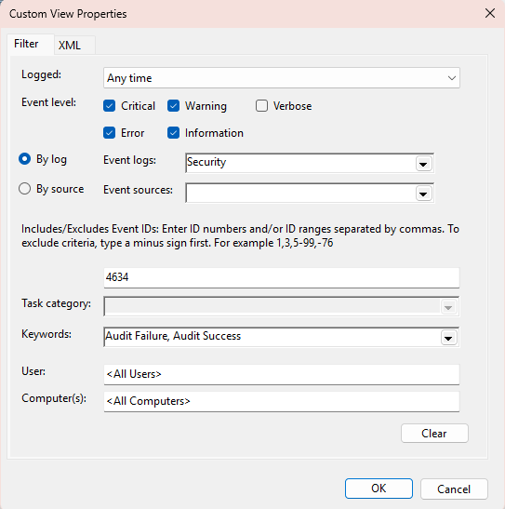
User Logs off
Figure 8 - Screenshot of Event ID 4634, indicating that a user has logged off the system

Event ID/s:
4634
Description :
This policy would alert the administrator of events pertaining to a user logging off.
Reasoning :
Audit Failures and Audit Success were selected due to the importance of knowing all failed and successful attempts. Furthermore, the Critical, Warning, Error and Information Event Levels were selected to have a complete picture of across the different levels of criticality.

Steps to enable auditing :

Launch gpedit.msc after utilizing Make me Admin to have administrative privileges for a PowerShell terminal, and then navigate to :
Computer Configuration à Windows Settings à Security Settings à Advanced Audit Policy Configuration à System Audit Policies – Local Group Policy Object

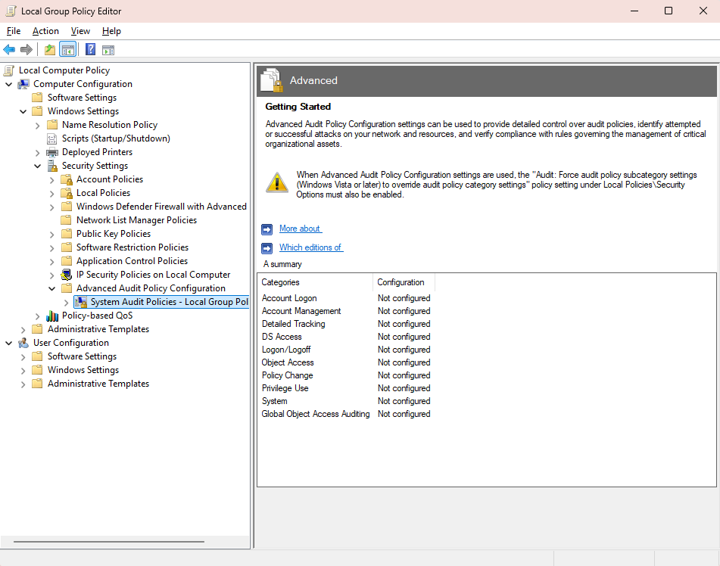
Figure 9 - Overview of available auditing options in Local Group Policy Editor

Here we see many different avenues for auditing! Let us proceed …

Account Management --> Audit User Account Management :
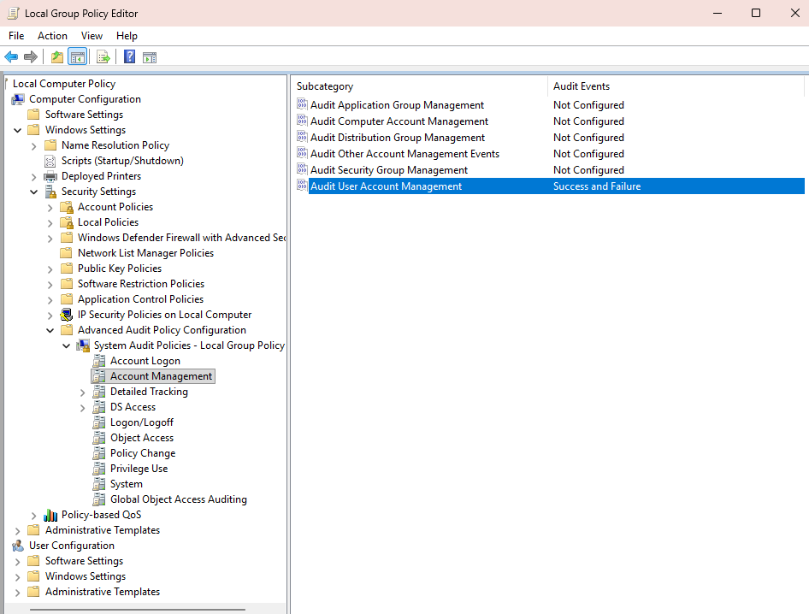

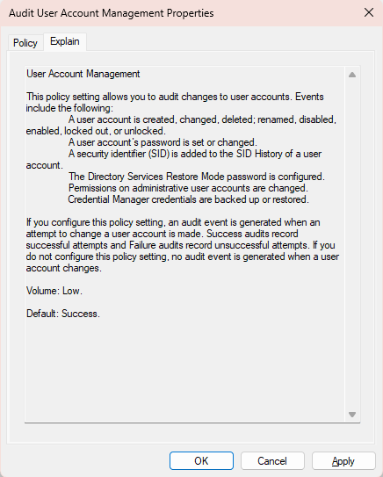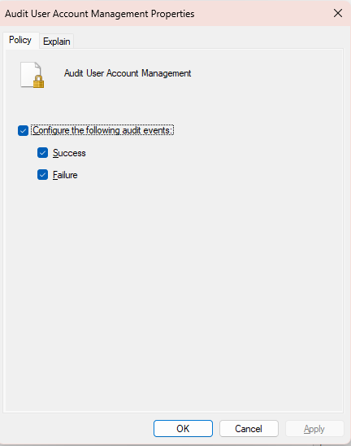
Figure 10 - Group Policy Editor showing audit settings for User Account Management
Significance:

This setting insures that all changes to user accounts are kept in check, including creation, deletion, group membership modifications and password resets. This is important from a defensive perspective, as privilege escalation is a common attack vector.

... followed by Logon/Logoff --> Audit Logon :

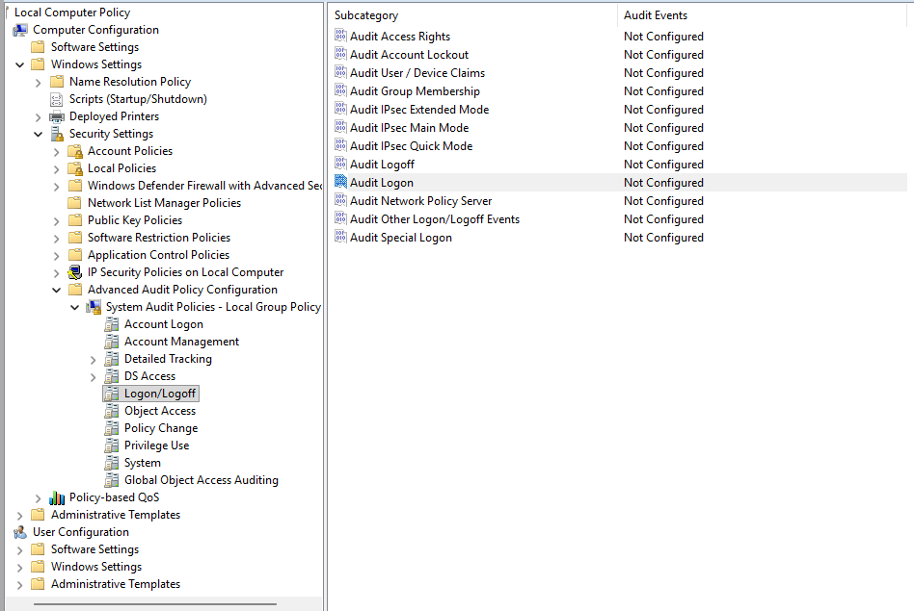

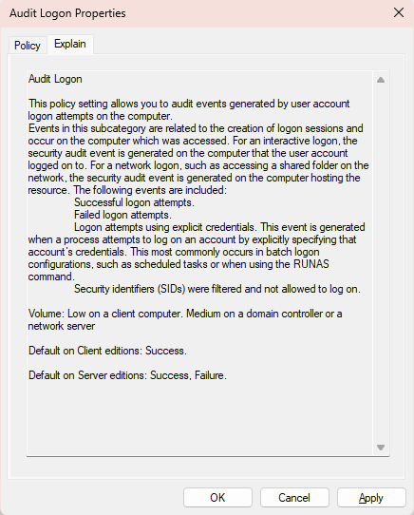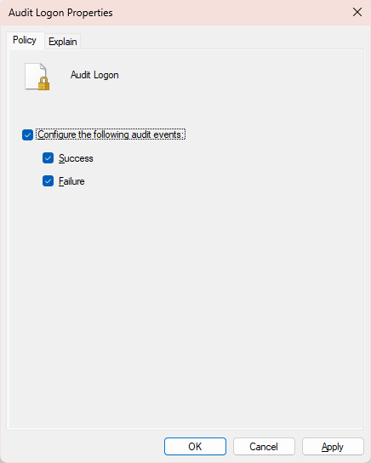
Figure 11 - Group Policy Editor showing audit settings for Logon events
Significance:
Auditing Logon events helps us form a clear picture of who is accessing the system, and then they are doing so. Failed logon attempts shows us that there is an attempt to gain access, which could be in the form of brute-force attempts, stolen credentials and account misconfiguration.
... followed by Logon/Logoff --> Audit Logoff :
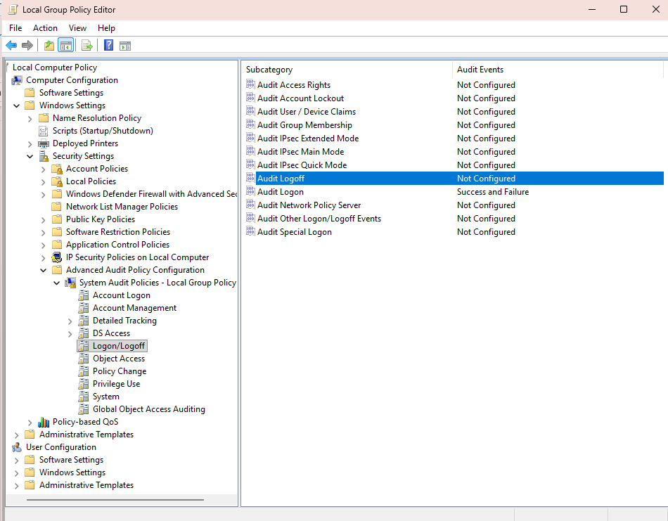
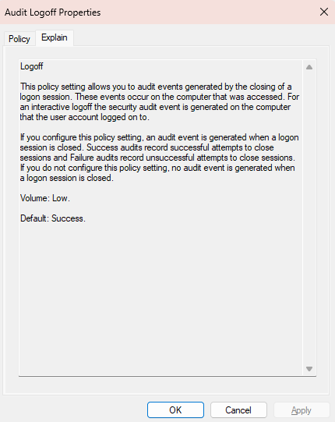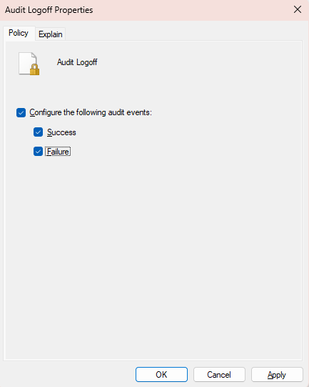
Figure 12 - Group Policy Editor showing audit settings for Logoff events
Significance:
Logoff events are complementary for successful logon events, as it tells us when a chain of events pertaining to an entity ended. These two types of events give us a complete timeline of a chain of events.

Next, we shift to the Policy Change --> Audit Audit Policy Change:

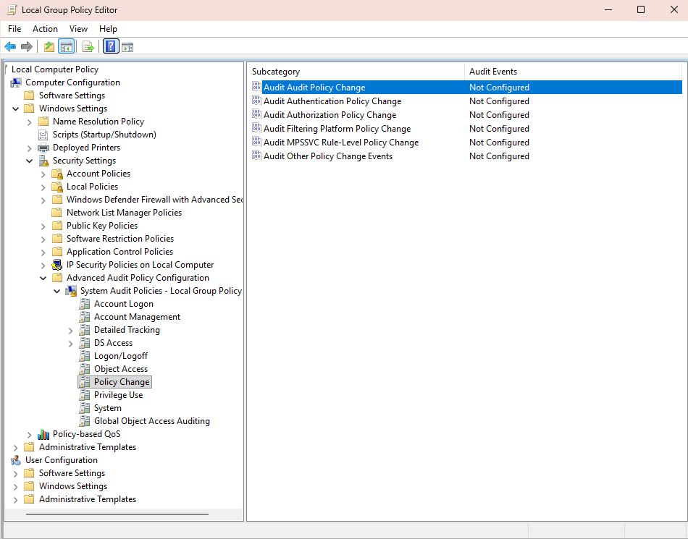
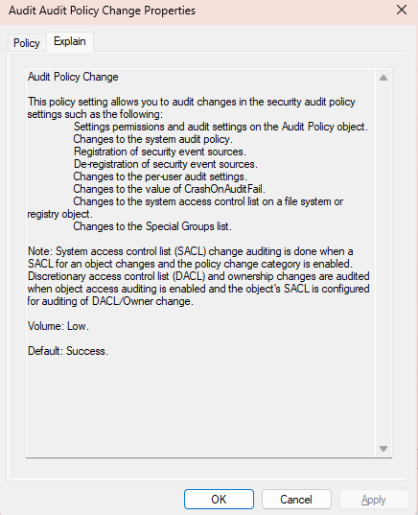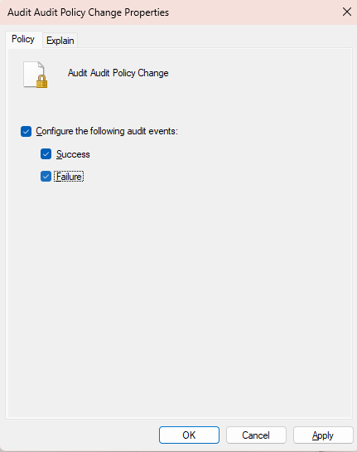
Figure 13 - Group Policy Editor showing audit settings for changes to audit policies
Significance:

Auditing audit policy changes would indicate to a defender a common tactic used by attackers, which is to cover their tracks by altering or disabling the auditing policy.

Next, we shift to the Object Access --> Audit Removable Storage:
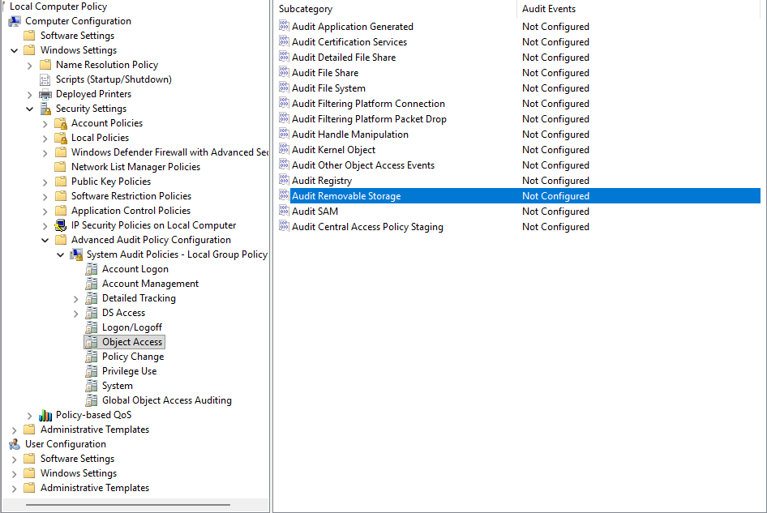
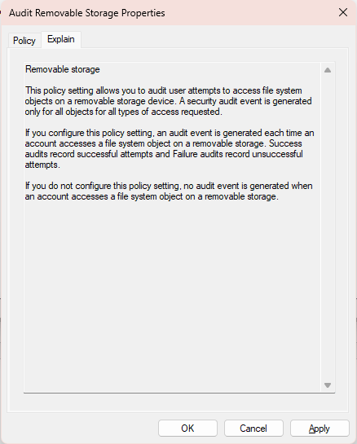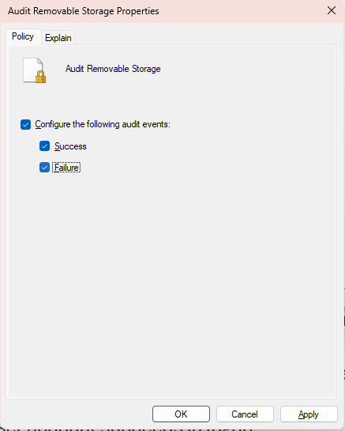
Figure 14 - Group Policy Editor showing audit settings for removable storage access
Significance:
Auditing removable storage access helps us in becoming aware of data exfiltration attempts. By logging actions taken against an external storage device, such as writing, copying or modifying content, we would quickly identify unauthorized data access.

... followed by Logon/Logoff --> Audit Account Lockout :

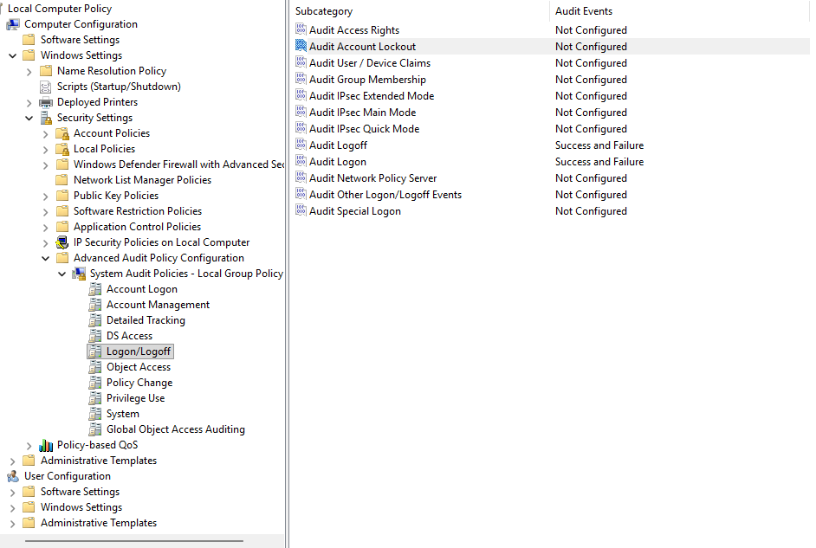
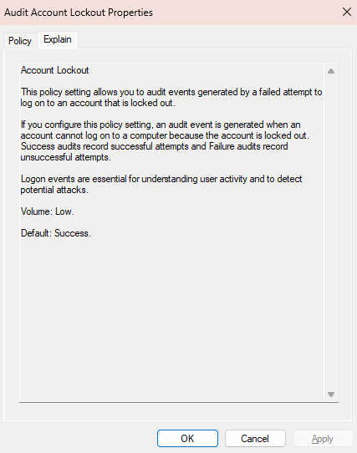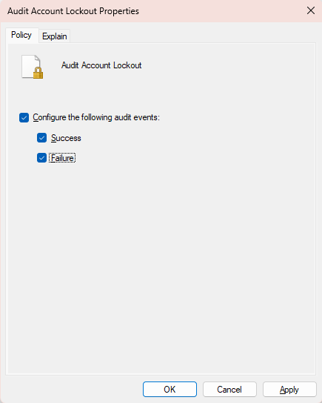
Figure 15 - Group Policy Editor showing audit settings for account lockout events

Significance:
Auditing incidents of account lockout is often another indicator of brute force attempts against an account.

… finally, I have opted to Audit Group Membership to track down any attempts to add the local user to the security-enabled groups :

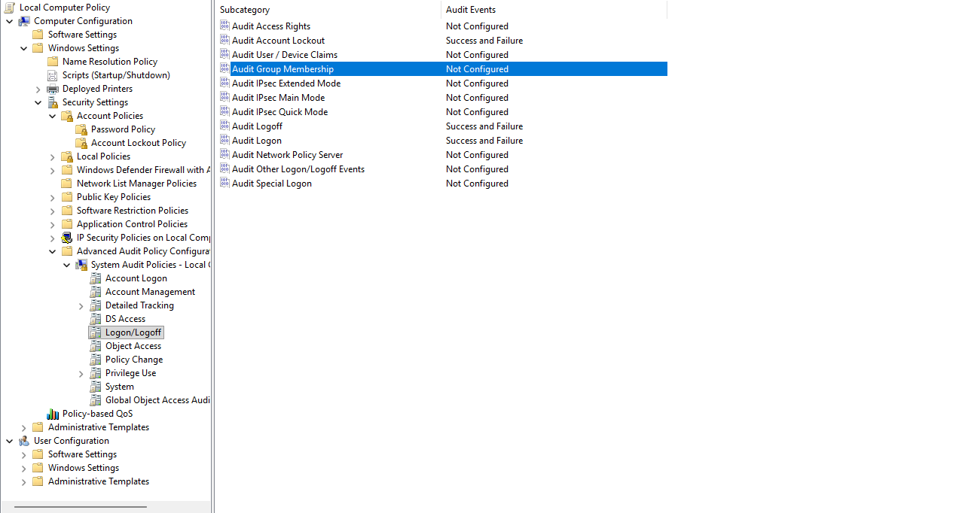
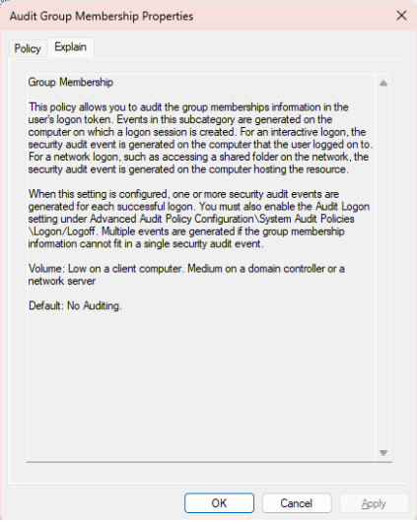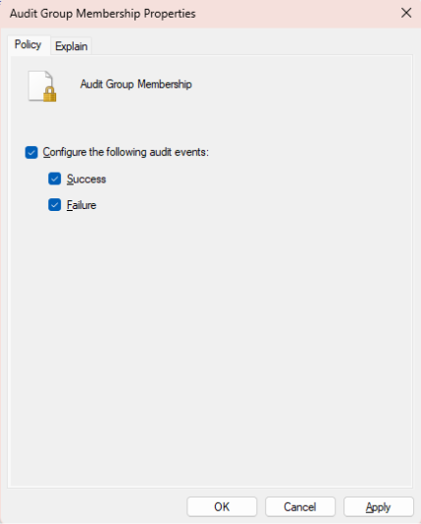
Figure 16 - Group Policy Editor showing audit settings for group membership changes

Significance:
Auditing group memberships is important for detecting any changes to security-enabled groups’ memberships. This would aid us in becoming aware of privilege-escalation attempts, which would happen in the form of adding a new user account to a privileged local/global group.

Task 2 – Event Creation
1. A User account is created

I have created a TestUser account with the Computer Management tool (compmgmt.msc launched via Windows Terminal with Administrative Privileges):
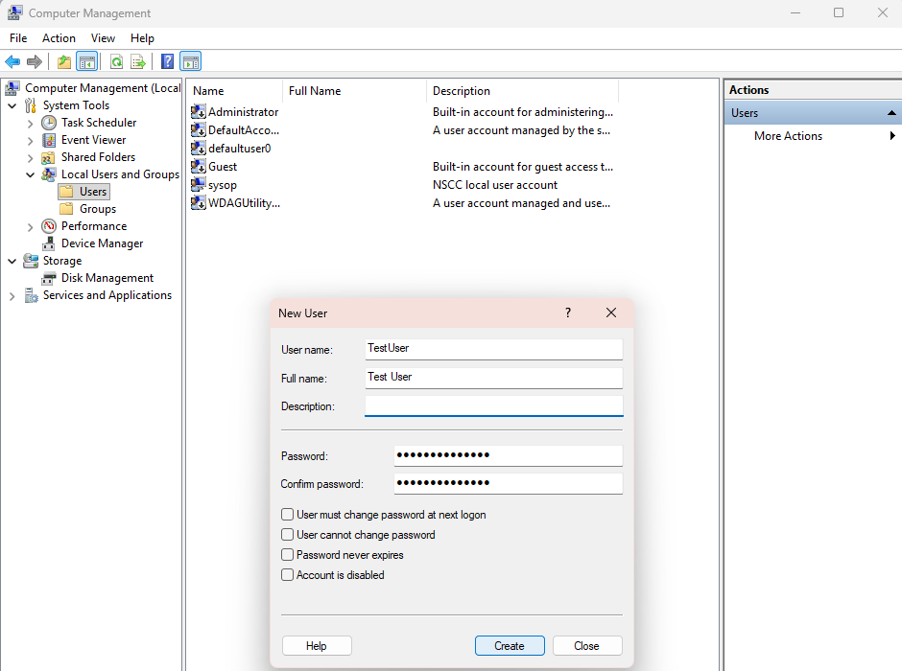
Figure 17 - Computer Management - New User Creation
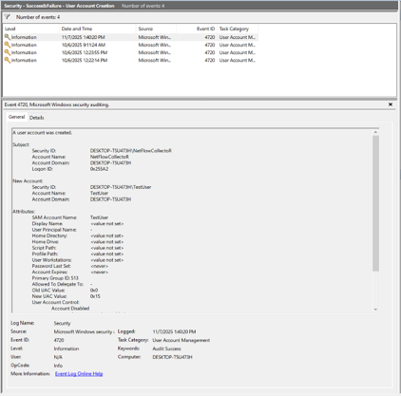
Figure 18 - User created successfully

2. User account fails to login due to an incorrect password.
Logged out of my user account, and typed the wrong password as the TestUser.
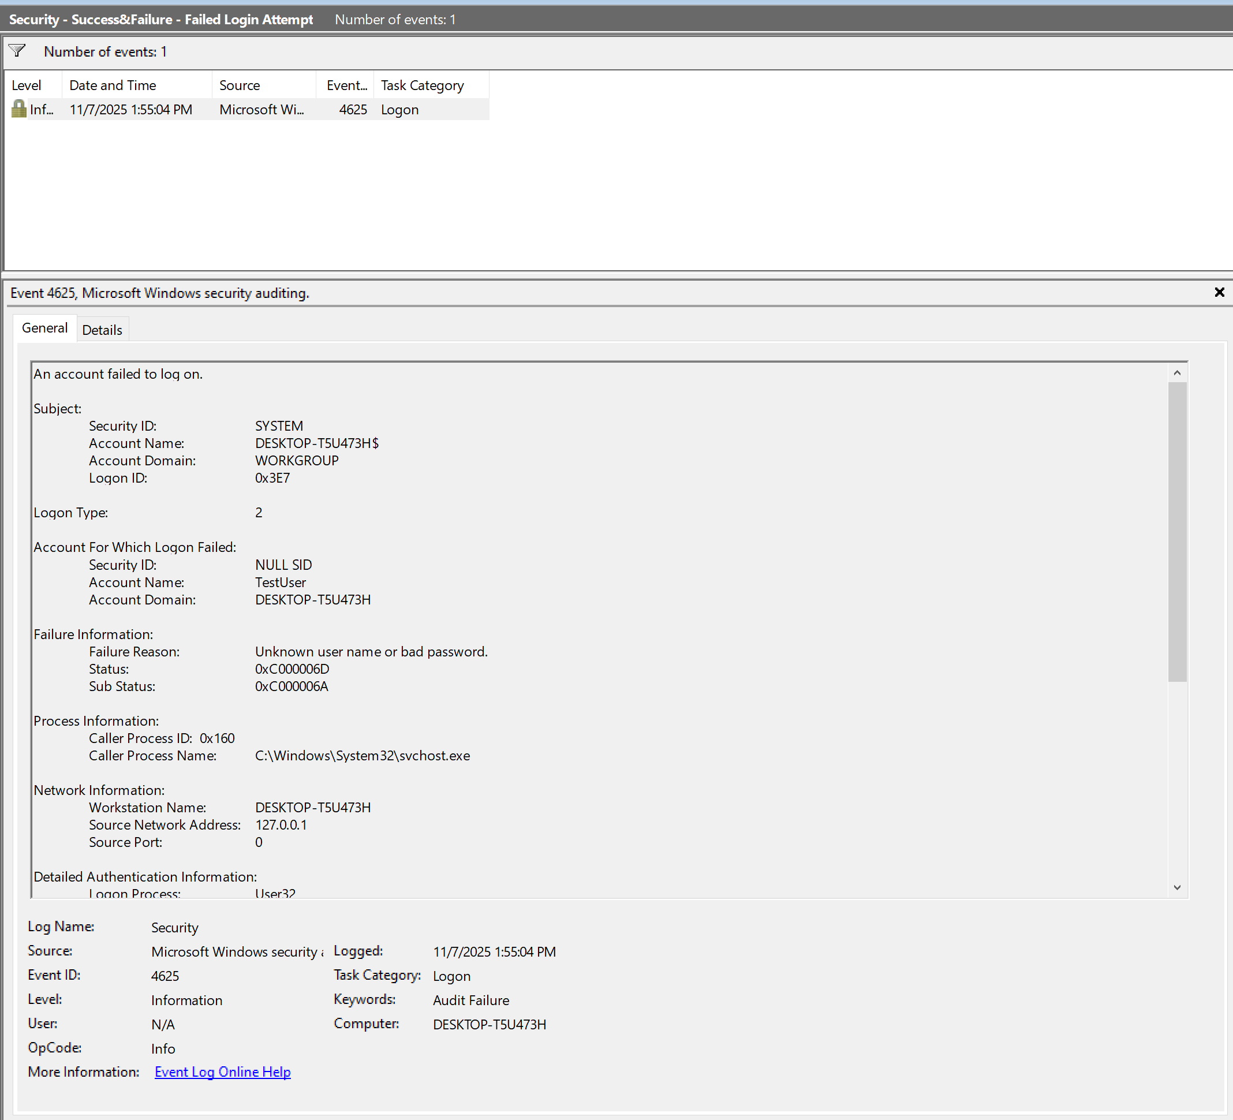
Figure 19- Failed Login Attempt for TestUser Due to Incorrect Password

3. User account succeeds in logon.
Logged in successfully by typing the correct password for TestUser.
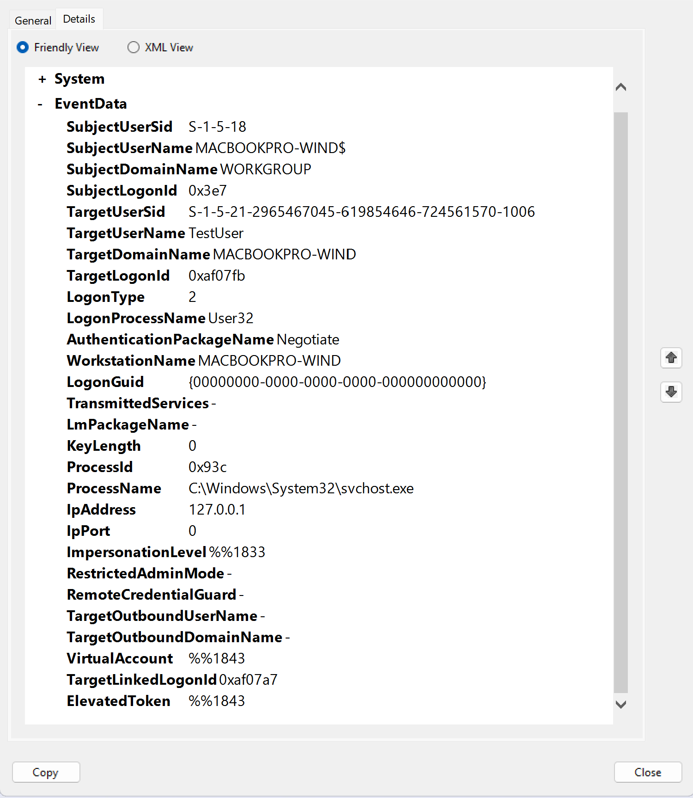
Figure 20 - Successful Logon for TestUser

4. User account is made a member of the administrators group.
I have utilized the Computer Management tool to do so, by selecting Local Users and Groups, followed by the Groups folder, followed by the selection of Administrators, right-clicking on the Administrators group and selecting “Add to Group” :
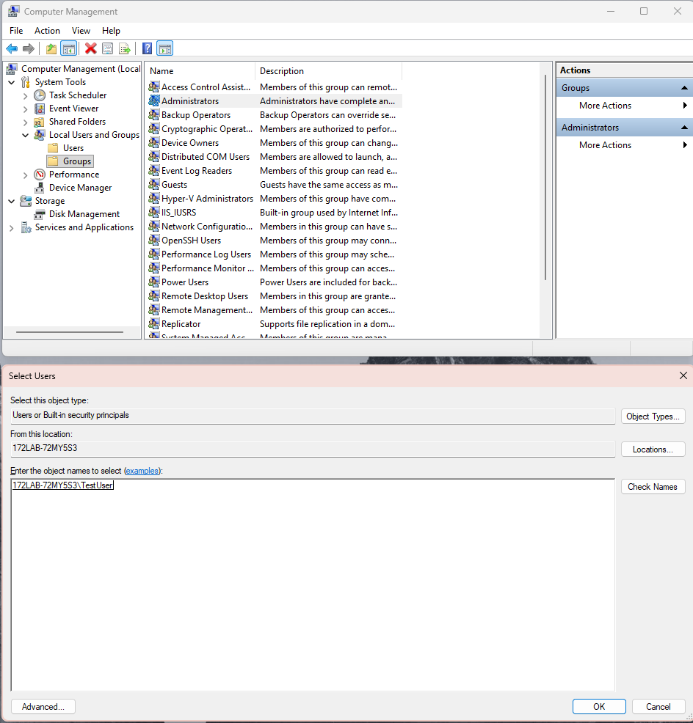
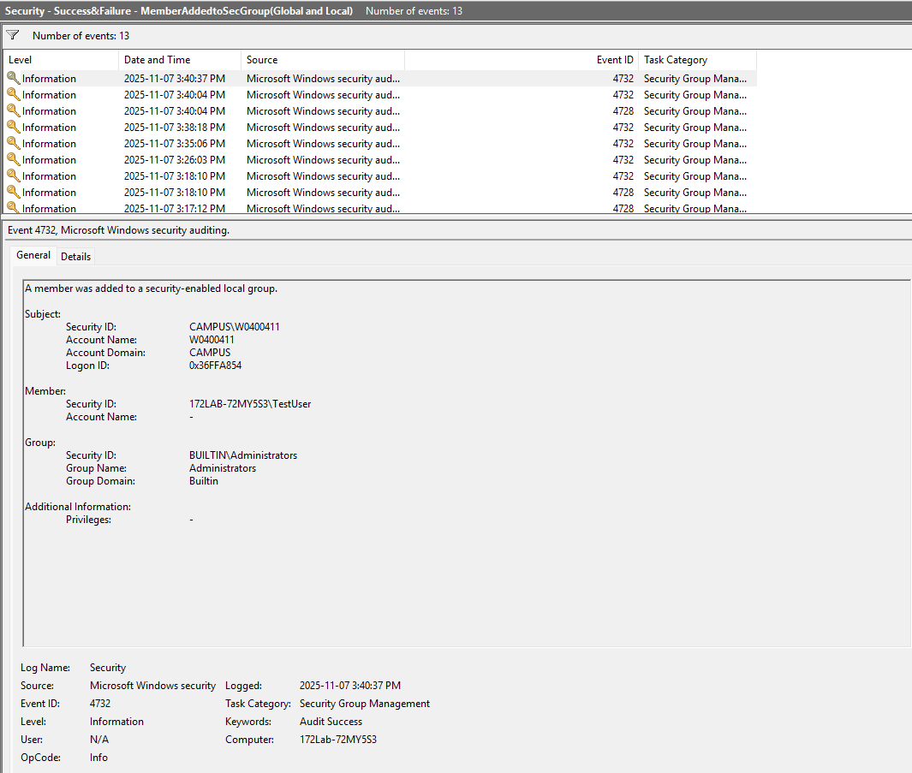
Figure 21 - Addition of TestUser to the Administrators' group

5. User account creates a scheduled task.
I have created a scheduled task as TestUser by creating a Scheduled Task in the Computer Management utility.
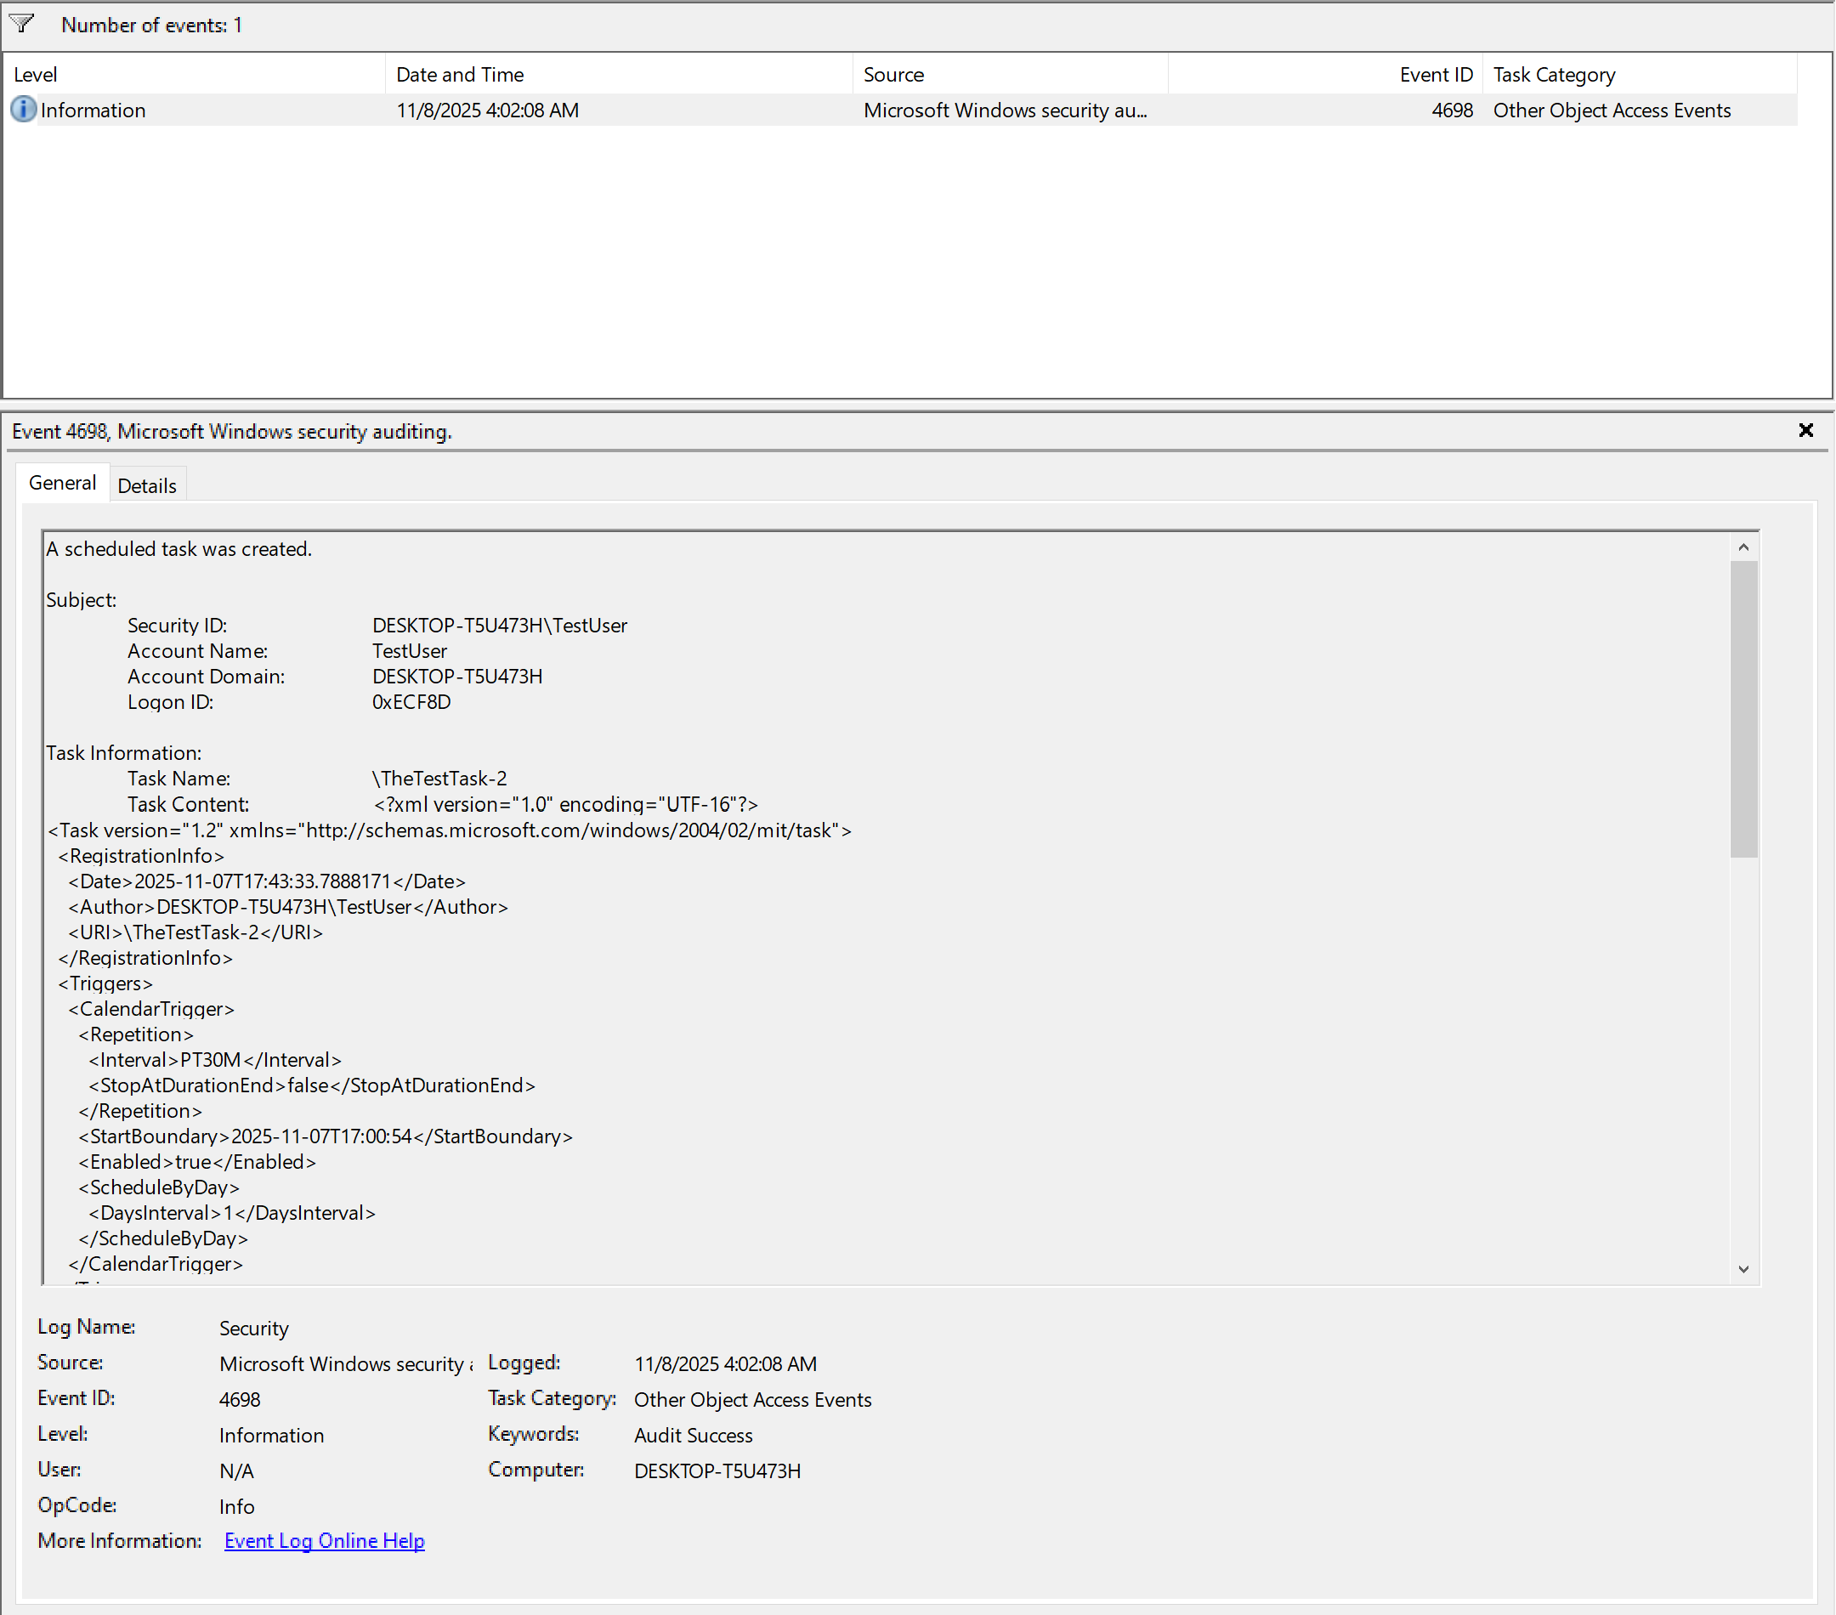
Figure 22 - Scheduled Task Creation by TestUser

6. User account accesses a USB key or other external storage media and writes a file to the device.
I have plugged in my flash drive as the TestUser, and created a .txt file called TestUser.txt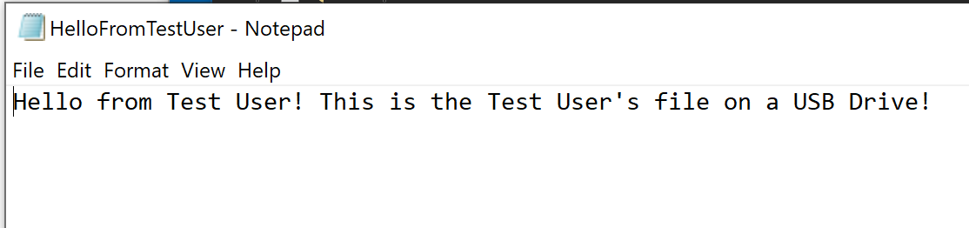
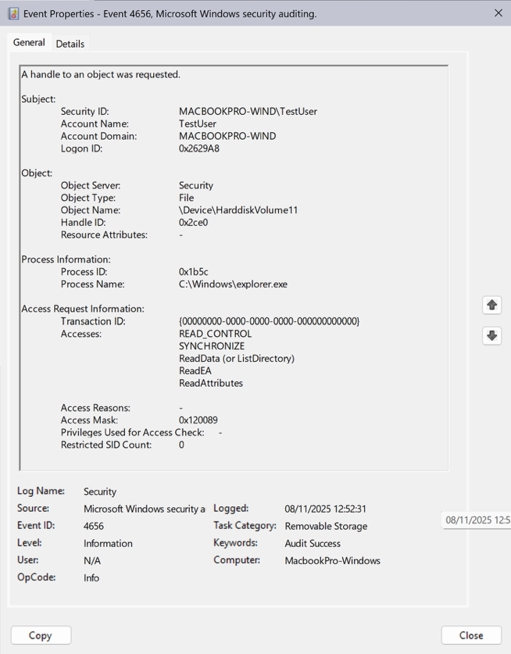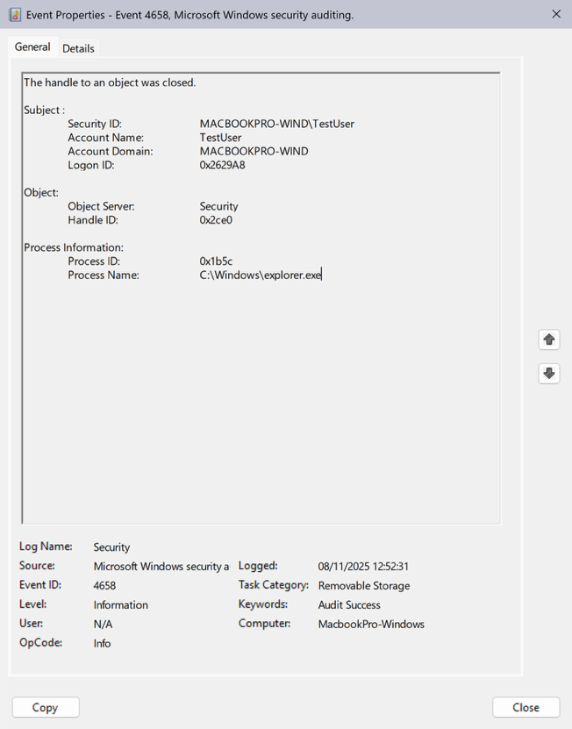
Figure 23 - Windows Event Viewer Logs: TestUser Writing a File to a USB Drive-Handle Request and Handle Release

Please note that I have noticed some difficulties of playing this scenario on a virtualized Windows 10 Education installation, where the process of plugging in the usb flash drive involves the vmware virtualization layer, where the process gets recorded under a SYSTEM account. Thus, I have reapplied all the audit policies and set up the Custom Views on Event Viewer on a bare-metal installation of Windows 11.

7. User account makes a change to an Audit Policy (i.e. stop logging failed logon attempts).
I have previously launched the Local Group Policy Editor tool as TestUser, and made a change to the Account Lockout Audit Policy
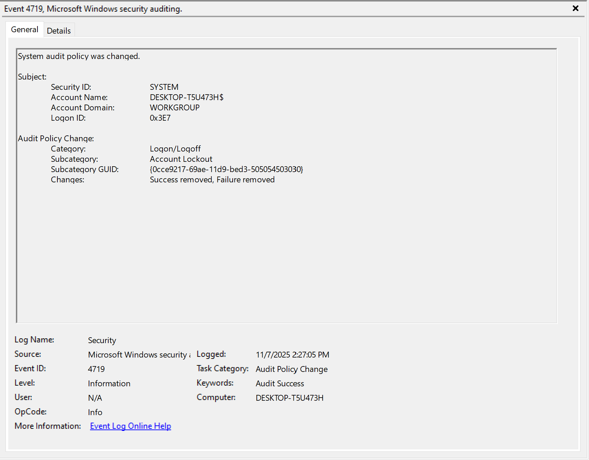
Figure 24 - Change made to the Account Lockout Audit Policy by TestUser

8. User account logs out.
I have logged out successfully as TestUser
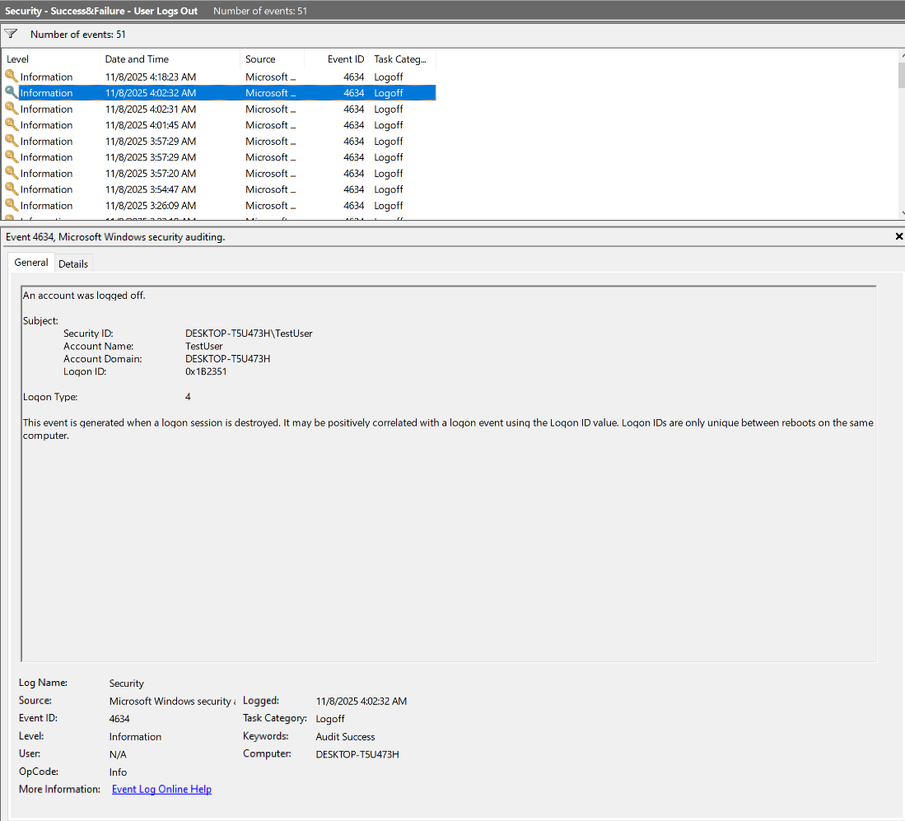
Figure 25 - TestUser logging out

Bibliography

Chapter 7 Object Access Events. (n.d.). Retrieved November 7, 2025, from https://www.ultimatewindowssecurity.com/securitylog/book/page.aspx?spid=chapter7#FileSys
Windows Security Log Event ID 4624—An account was successfully logged on. (n.d.). Retrieved November 5, 2025, from https://www.ultimatewindowssecurity.com/securitylog/encyclopedia/event.aspx?eventid=4624
Windows Security Log Event ID 4656—A handle to an object was requested. (n.d.). Retrieved November 7, 2025, from https://www.ultimatewindowssecurity.com/securitylog/encyclopedia/event.aspx?eventid=4656
Windows Security Log Event ID 4658—The handle to an object was closed. (n.d.). Retrieved November 7, 2025, from https://www.ultimatewindowssecurity.com/securitylog/encyclopedia/event.aspx?eventID=4658
Windows Security Log Event ID 4663—An attempt was made to access an object. (n.d.). Retrieved November 6, 2025, from https://www.ultimatewindowssecurity.com/securitylog/encyclopedia/event.aspx?eventid=4663
Windows Security Log Event ID 4698—A scheduled task was created. (n.d.). Retrieved November 6, 2025, from https://www.ultimatewindowssecurity.com/securitylog/encyclopedia/event.aspx?eventid=4698
Windows Security Log Event ID 4728—A member was added to a security-enabled global group. (n.d.). Retrieved November 6, 2025, from https://www.ultimatewindowssecurity.com/securitylog/encyclopedia/event.aspx?eventid=4728
Windows Security Log Event ID 4732—A member was added to a security-enabled local group. (n.d.). Retrieved November 6, 2025, from https://www.ultimatewindowssecurity.com/securitylog/encyclopedia/event.aspx?eventid=4732
Windows Security Log Event ID 6416—A new external device was recognized by the system. (n.d.). Retrieved November 7, 2025, from https://www.ultimatewindowssecurity.com/securitylog/encyclopedia/event.aspx?eventid=6416

